Randomized Initialization Protocols for Packet Radio Networks
Tatsuya Hayashi, Koji Nakano, Stephan Olariu
In Proc. 13th IEEE International Parallel Processing Symposium and 10th IEEE Symposium on Parallel and Distributed Processing (IPPS/SPDP’99), 1999
Abstract
The main contribution of this work is to propose efficient randomized leader election and initialization protocols for Packet Radio Networks (PRN, for short). As a result of the initialization protocol, the n stations of a PRN are assigned distinct integer IDs from 1 to n.
- Introduction
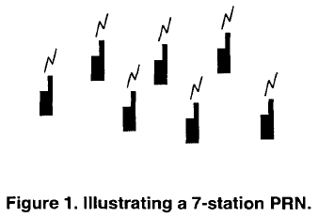
- Initializing the PRN with CD
  - Initializing the single-channel PRN
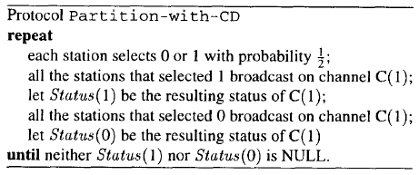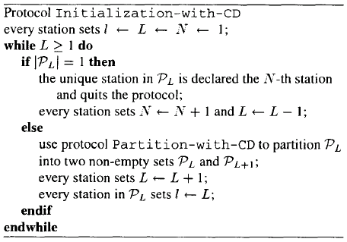
An n-station PRN with CD can be initialized in O(n) rounds with probability at least 1-1/2^n.

  - Initializing the k-channel PRN
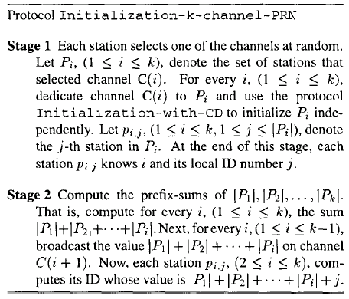
The k-channel PRN with CD can be initialized in O(n/k) rounds with probability at least 1-1/n, whenever k <= n/(3log n).
- Initializing the PRN with CD
  - Leader election on the PRN with no CD
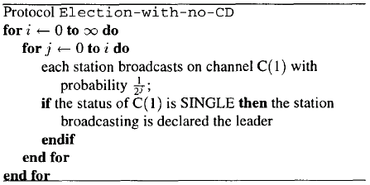
Protocol Election-with-no-CD elects a leader in O((log n)^2) broadcast rounds with probability at least 1-1/n. or in O(n) broadcast rounds with probability at least 1-1/(2^(2^(1/2)).

  - Initializing the PRN with no CD
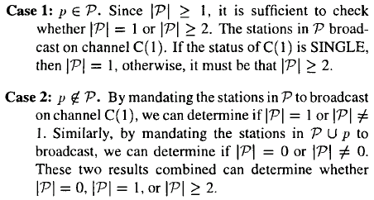
The single-channel, n-station PRN with no CD can be initialized in O(n) broadcast rounds with probability at least 1-1/(2^(2^(1/2)).
The k-channel PRN with no CD can be initialized in O(n/k) rounds with probability 1-O(1/n), whenever k <= n/(4(log n)^2).
Created by: Chia-Mao Huang
Date: Apr. 18, 2000

